Profile page

# Public & private modes

The profile page had 2 different modes, all dynamically displayed on the same HTML page.  
The current mode would be specified by the web framework after which the relevant fields as described in “Layout” below would be displayed (or hidden).

## Public

Any given user’s profile page, with only elements relevant to the public user displayed

## Private

The logged in user’s profile page with more private information that can be edited.

# Layout

## Sidebar

Here, the username, user’s own name, a user bio, and the number of upvotes received by the user, is displayed. In private mode, these (except for upvotes) can all be edited, as well as the user’s bookmarks and password.

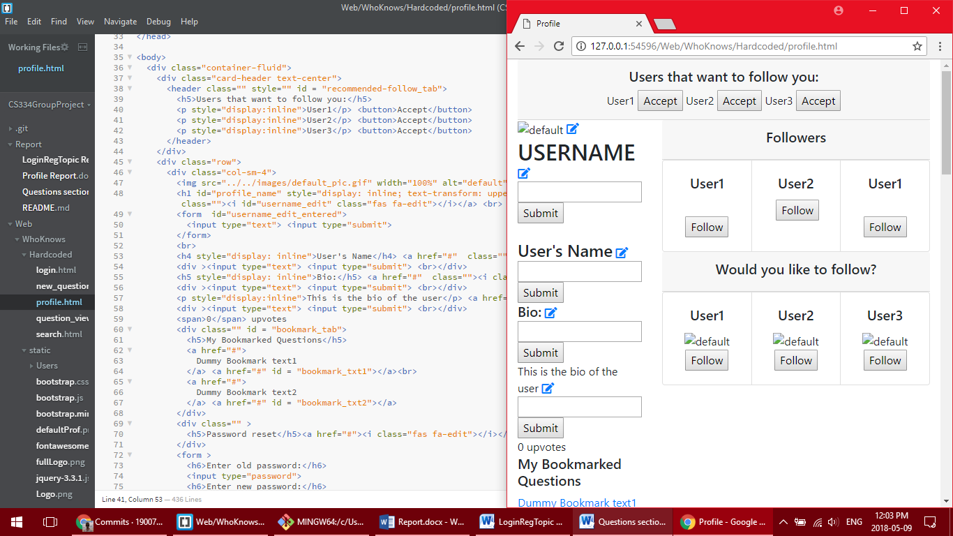 Edit icons will appear in private mode.

## Followers

The user’s followers are displayed next to the sidebar, and if in public mode, one has the option to follow these users. There are also follow suggestions for private mode, and above it, follow requests for the user.

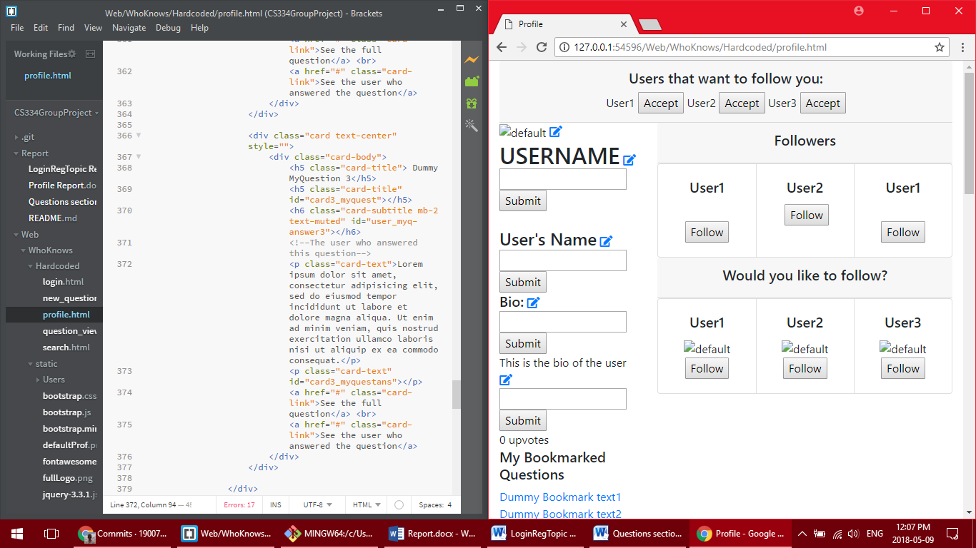Appears at the top in private mode

Follow buttons after each follower of this user, appear in public mode. “Would you like to follow?” appears in private mode only.

## Qs and As

When in public mode, the user’s top questions and answers will be displayed and sorted by number of upvotes. There will be links to the full question and also to the answer itself.  
When in private mode, there will be a full list of all the user’s questions, and another of all their answers, with links to each respective one added.

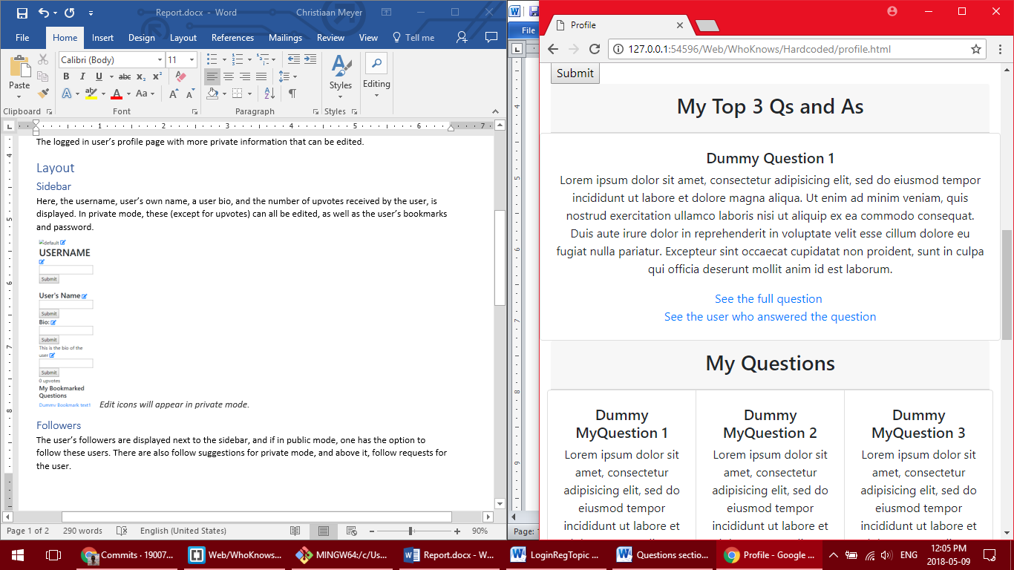In public mode

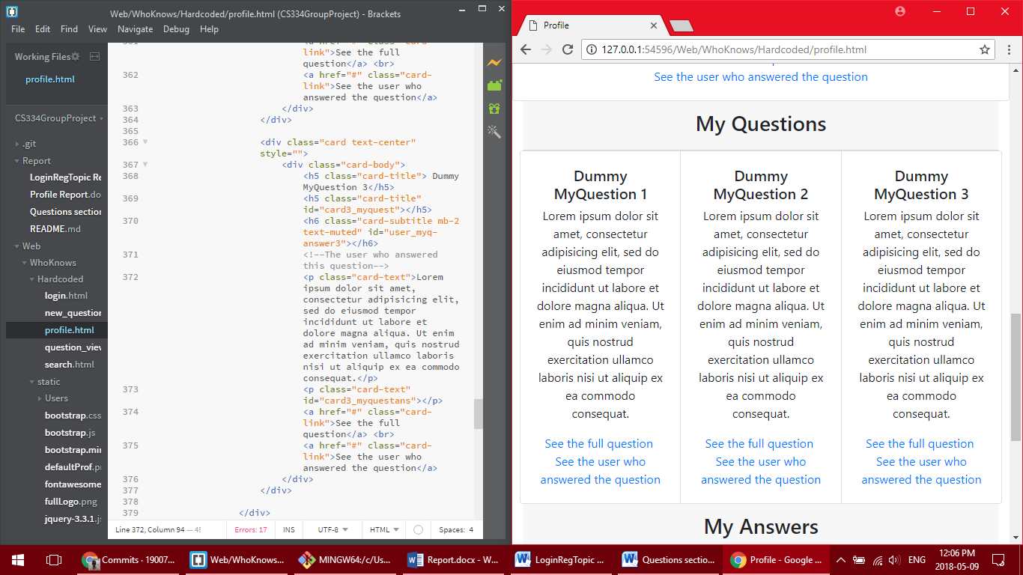In private mode

## Topic suggestions

In private mode, the user will be able to view topics that they can follow.

# Contributors to this section

Technically, Mr CJ Meyer and Mr Jason George were in charge of this section. However, the bulk of the work was done by Mr Pieter Goos, who handled the entire database implementation (to my knowledge, but possibly others assisted) and who had restructured this entire profile page to satisfaction. I, Mr CJ Meyer, unfortunately did not work on this page too much, and marks may be reflected as such. I do, however, commend the rest of my teammates - once again with special commendation to Mr Goos - for their hard work and studious effort.